New Chief Operations Officer (COO)
at Glen Dimplex Deutschland:
Dr. Horst Andreas Arnet.
Kulmbach.- On August 15, 2020, Dr. Horst Andreas Arnet (53) was appointed the new Chief Operations Officer at Glen Dimplex Deutschland GmbH, assuming overall responsibility for the Operations function as a member of the management board. In his new role, Dr. Arnet has assumed responsibility for managing and organising all the operational processes and services for the Dimplex and Riedel brands. He reports directly to the managing director Clemens Dereschkewitz.

Horst Arnet graduated from the Friedrich-Alexander University of Erlangen-Nuremberg with a degree in engineering, majoring in mechanical engineering/production engineering, and subsequently wrote his doctoral thesis in the Faculty of Manufacturing Technology. Starting in 1999, he held various posts, with increasing levels of responsibility, within the Schaeffler Group. Among other roles, he headed the group's global tooling and prototyping division.

Managing Director of Glen Dimplex Deutschland Clemens Dereschkewitz comments: “We are delighted to welcome Horst Arnet as an experienced new member of our management team. We would also like to place on record our thanks to Stephen Nixon for his commitment as interim COO, and wish him all the best and every success in his future projects.”

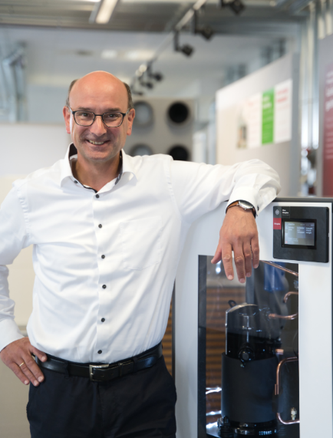
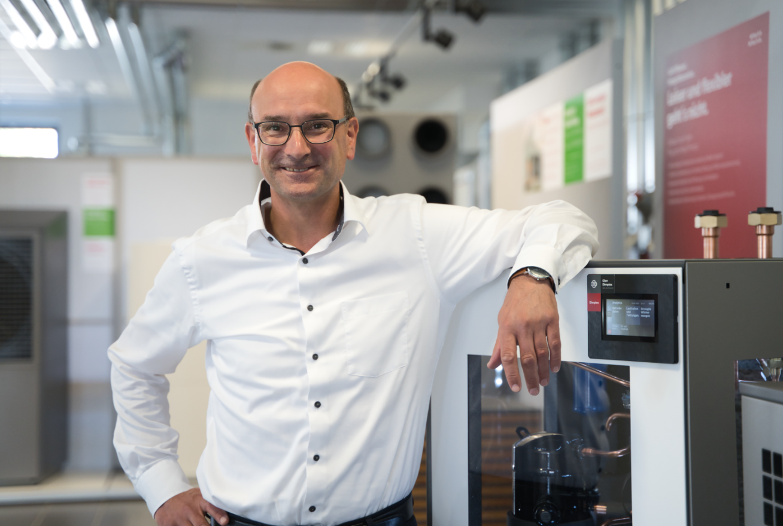

Image caption: Dr. Horst Andreas Arnet was appointed the new Chief Operations Officer (COO) of Glen Dimplex Deutschland on August 15, 2020.

About Glen Dimplex Deutschland and the Glen Dimplex Group:
Glen Dimplex Deutschland is part of the international Glen Dimplex Group based in Ireland - a leading international supplier of electric heating solutions and domestic appliances.
Glen Dimplex Deutschland combines the group’s global knowledge and expertise in the development of highly efficient system solutions for heating, cooling and ventilation of buildings, as well as commercial and industrial applications and supplies the Dimplex, Riedel and Koolant Koolers brands. As well as the headquarters in Kulmbach, Glen Dimplex Deutschland also has subsidiaries in Kalamazoo (USA) and Shenyang (China). The company is managed by CEO Clemens Dereschkewitz.
At its HQ in Kulmbach, Glen Dimplex has stood for expertise in heating and refrigeration for over 40 years. This is where energy-efficient heating and air-conditioning systems are designed by our engineers and technicians at our in-house Development department and perfected to market maturity. Products from Glen Dimplex are a byword for engineering expertise, quality and “Made in Germany” design. Glen Dimplex Deutschland's worldwide locations employ around 1,000 people.

Contact:
Henrik Rutenbeck, Director Marketing
E henrik.rutenbeck@glendimplex.de
M +49 (0) 151 571 37 570

